Project Report

- Introduction and problem statement

Educational institutions collect large amounts of data related to student’s study habits, attendance, and academic history. Understanding how these factors influence academic success can help educators provide targeted support.
This project aims to model the relationship between student behavioral features and academic performance using supervised machine learning. Specifically, we will learn a linear regression model that predicts the final student grades while minimizing squared error loss. Three different methods will be tested along with the baseline model for referencing to determine the best fit model.

- Dataset and preprocessing

We have utilized the Student Performance Dataset from the UCI Machine Learning Repository for this project’s goals. It consists of 395 student records (n) from two Portuguese secondary schools (the equivalent to a U.S. High School). The dataset contains 33 features (d) representing academic, demographic, and social factors for the students. Our objective is to predict their final grade (column G3 in the dataset). The input feature matrix is defined as X ∈ R^{n*d} and the target output vector as y = G3 ⇒ y ∈ R^{n}.

The data was prepared and preprocessed for our linear regression models by implementing the following steps:

- Loading & Inspection: The raw data was imported and audited to confirm structure/shape and feature types.
- Variable Definition (I/O): The target variable (y) was isolated from the predictor features (X).
- Categorical Encoding: The data’s non-numerical features (e.g., school, gender, address) were transformed into numerical values using one-hot encoding for compatibility with the mathematical regression models.
- Missing Values: The dataset was checked for null values and if found, handled with imputation.
- Feature Scaling: Input features were standardized and normalized to ensure a uniform magnitude across all the predictors (features), preventing bias toward features with large numerical ranges.
- Data Partitioning: Lastly, the processed dataset was then divided into the customary 80/20% Training and Testing set (Train/Test Split) for unbiased model evaluations.

- Models used

We evaluate student performance in this project by employing a baseline reference and three distinct machine learning algorithms. These separate models were selected to provide us with multiple perspectives of the data, from simpler linear assumptions to non-parametric local estimation.

Baseline Model (Mean Predictor)
The baseline model is our performance benchmark. It calculates the mean final grade of the training set and then applies that constant value as a prediction for every instance in the test set. This provides us with a basic reference point; an effective learning model should outperform this baseline.
Method 1: Linear Regression
Our primary model uses Ordinary Least Squares (OLS) for capturing linear relationships between the features (X) and the final grade (y). It assumes that the target variable is a weighted sum of the input features, which provides us with an interpretable view of how individual factors (e.g., study time) directly influence a student’s academic outcome.
Method 2: Ridge Regression
This method is an extension of linear regression that incorporates L2 regularization, which adds a penalty term proportional to the square of the magnitude of coefficients. The algorithm is used to reduce model complexity and prevent overfitting, which is particularly useful for our dataset given its high dimensionality (d = 33) relative to the sample size (n = 395).

Method 3: K-Nearest Neighbors (KNN) Regression
Our third algorithm used is a non-parametric algorithm that predicts a student’s grade by basing it on the average performance of their “local neighborhood” – with the hyperparameter k representing the most similar students in the feature space (k = 5 in our implementation). KNN is different from our previous models because it does not assume a specific functional form. This allows it to capture complex, non-linear patterns that may be hiding within the student population data.

- Results and analysis

Principal Component Analysis (PCA) was used initially to reduce the 33 dimensions down to 2 principal components for visualizing student distribution. Our resulting scatter plot shows a single dense cluster of students concentrated near the center. This shows no distinct isolated sub-populations or demographic splits. Following PCA, the performance results are as follows.
Ridge Regression (Method 2) achieved the top overall performance, which shows that adding the L2 penalty successfully managed the dataset’s 33 features and prevented overfitting.
Linear Regression (Method 1) performed extremely close to Ridge Regression, with it explaining approximately 72.413% of the variance in final student grades.
KNN Regression (Method 3) surprisingly struggled quite significantly compared to the previous linear models, producing a much higher error rate (MSE of 11.407) while explaining only approximately 44.369% of the final student grade variance. This method’s results suggest that the relationship between the specific behavioral features and final grades is predominately linear rather than localized.
Finally, the actual versus predicted plot for the linear regression model shows a tight alignment along the identity line across the mid and high-grade tiers. There are also substantial prediction errors for the students whose actual final grade was 0, where this algorithm over-predicted the majority.

- Visualizations

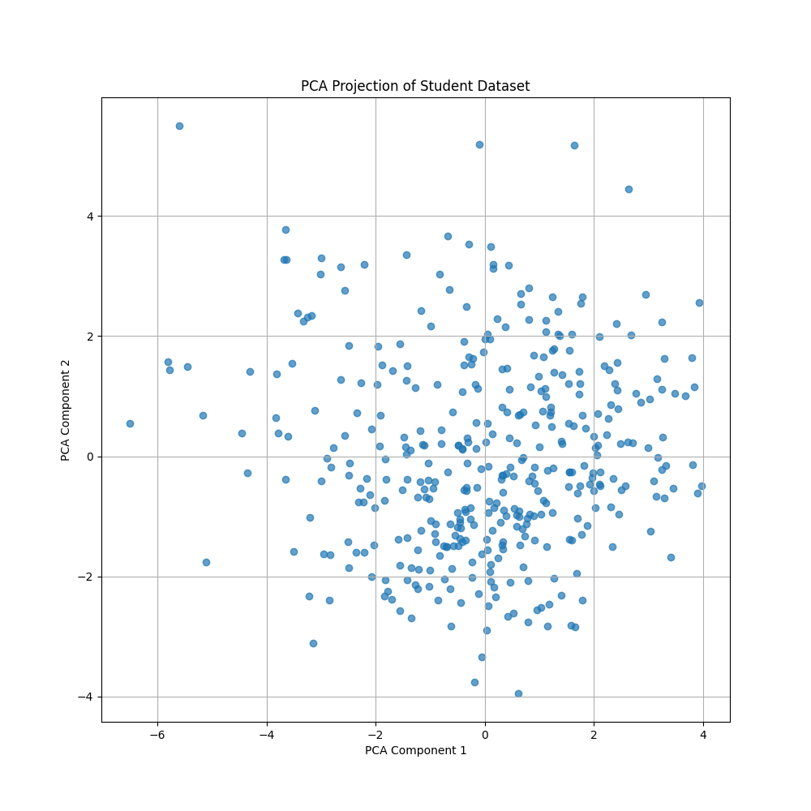

Model | MSE | RMSE | R2 Score
Baseline | 21.0045165 | 4.583068459 | 0
Linear Regression | 5.656642833 | 2.378369785 | 0.724134124
Ridge Regression | 5.644375514 | 2.375789451 | 0.724732382
KNN Regression | 11.40708861 | 3.377438172 | 0.44369362

